|  |
| --- |
| Date/Location |
| 03/04/2022 @Zoom |

|  |  |
| --- | --- |
| Attendees | |
| Client | MAVDEV |
| Joe Saceric | Ammar Lokhandwala |
| Umera Khan | Maria Frausto |
|  | Michael Gurch |
|  | Victoria Sheraden |

|  |
| --- |
| Meeting Agenda |

1. **Current Trello Board**

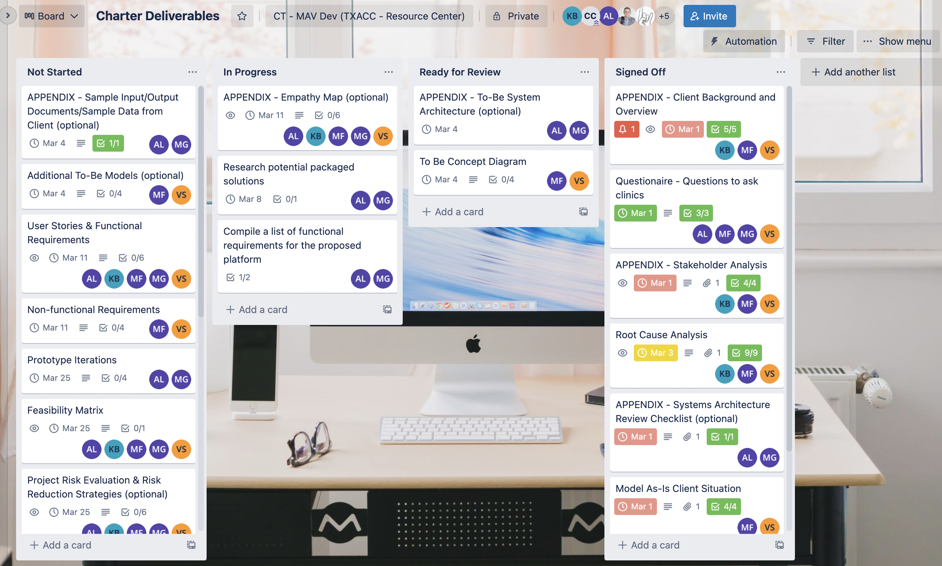

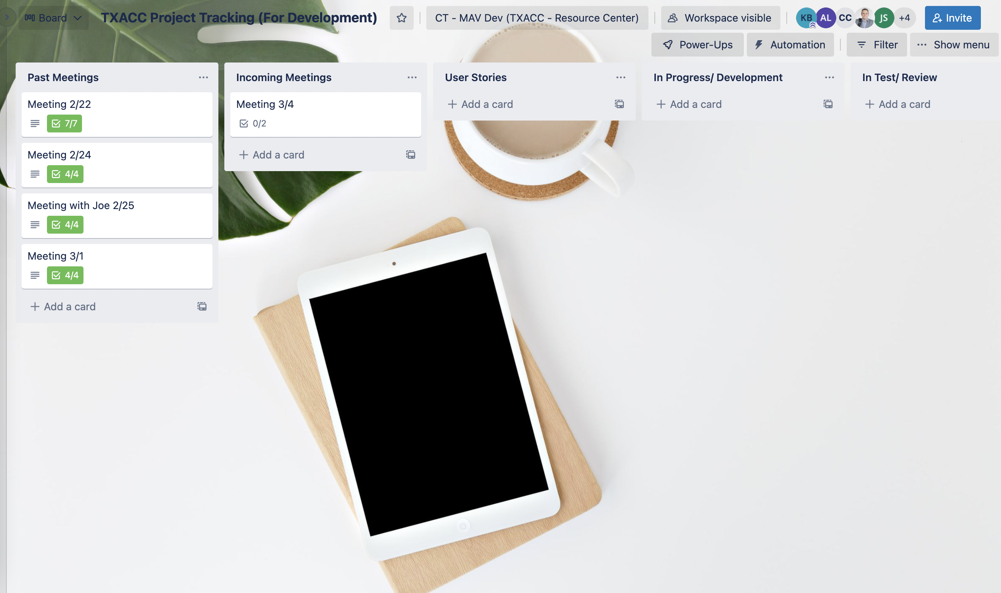

1. **Discussion Agenda**
2. Review To-be Diagrams
3. Review Q&A List
4. **Project Tracking**

* Project Tracking (For Meetings and Development)

<https://trello.com/b/r8DXAHG0>

* For Charter Deliverables

<https://trello.com/b/sucG4Wpv>